**DBMS PRACTICALS**

**EX-1**

1. Create a table name STUDENT with following structure.

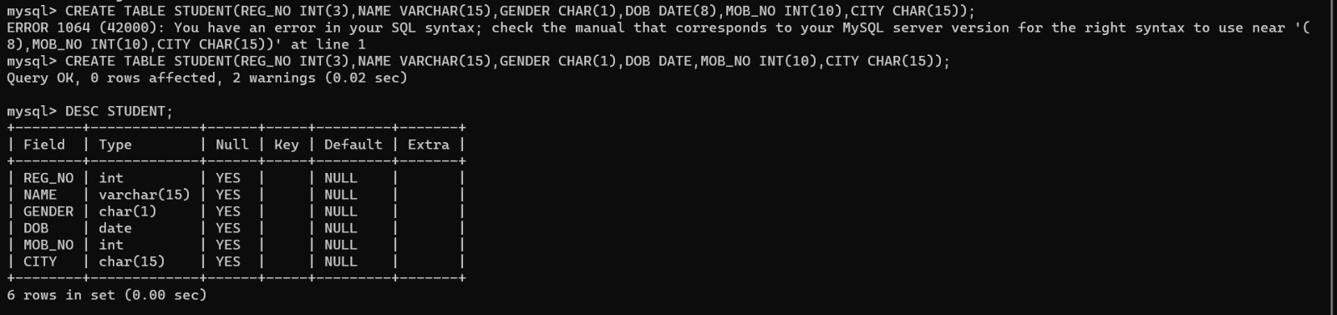

1. Create a table name FACULTY with following structure.

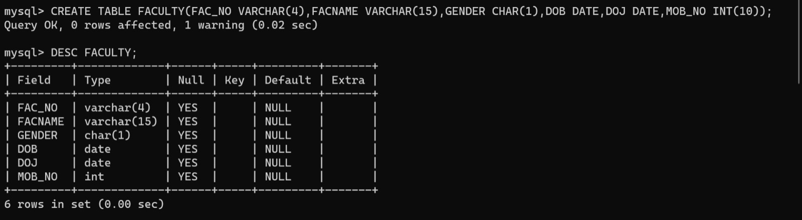

1. Create a table name DEPARTMENT with the following structure.

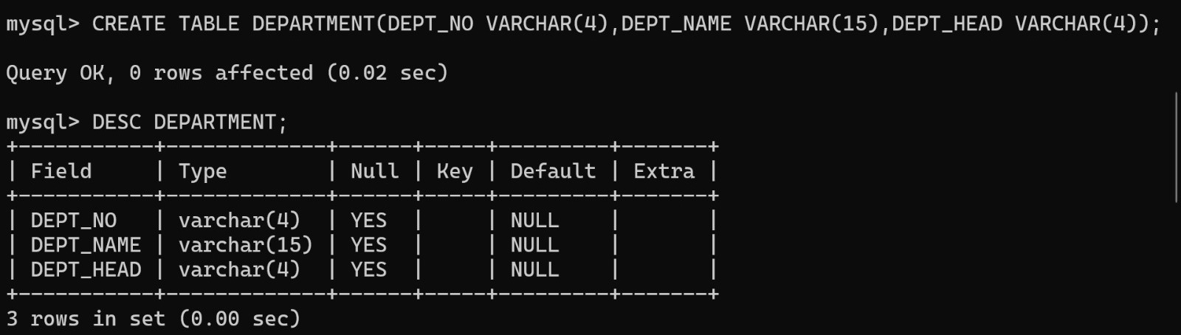

1. Create a table name COURSE with the following structure.

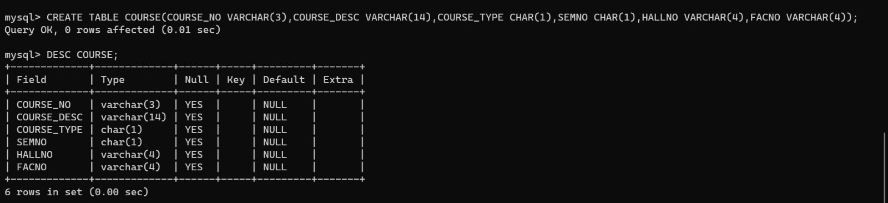

1. Modify the table FACULTY by adding a column name DeptNo of datatype varchar(4)

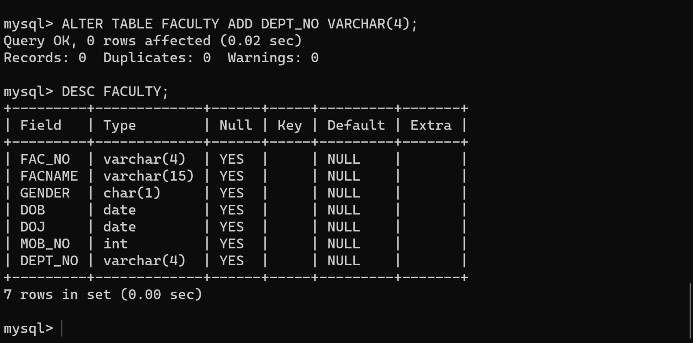

EX-2

1.Alter the table STUDENT with following structure.

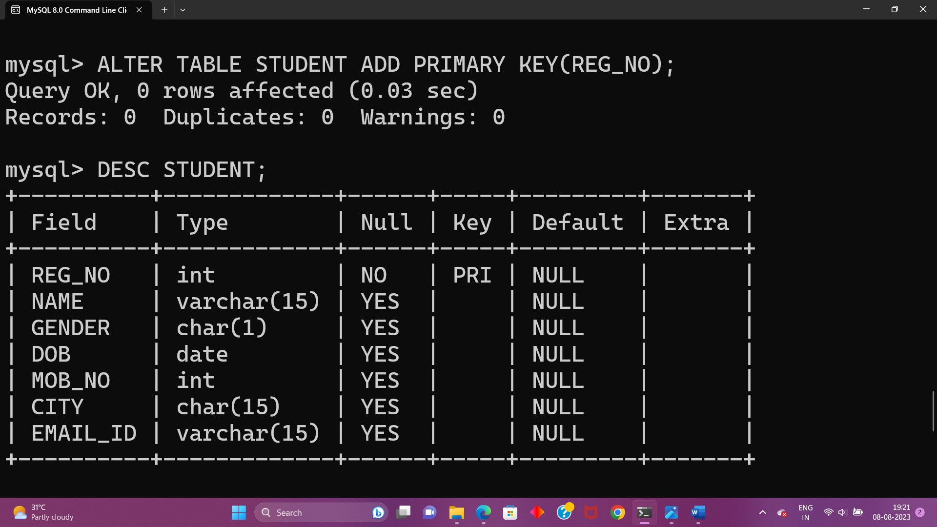

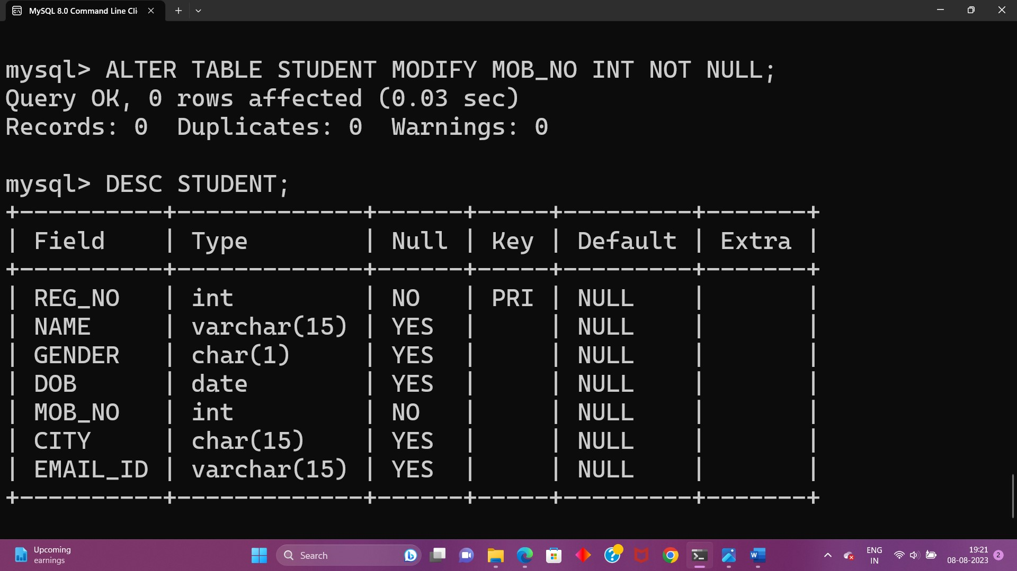

2.Alter the table name FACULTY with following structure.The DeptNo in this table refers to the Department table.

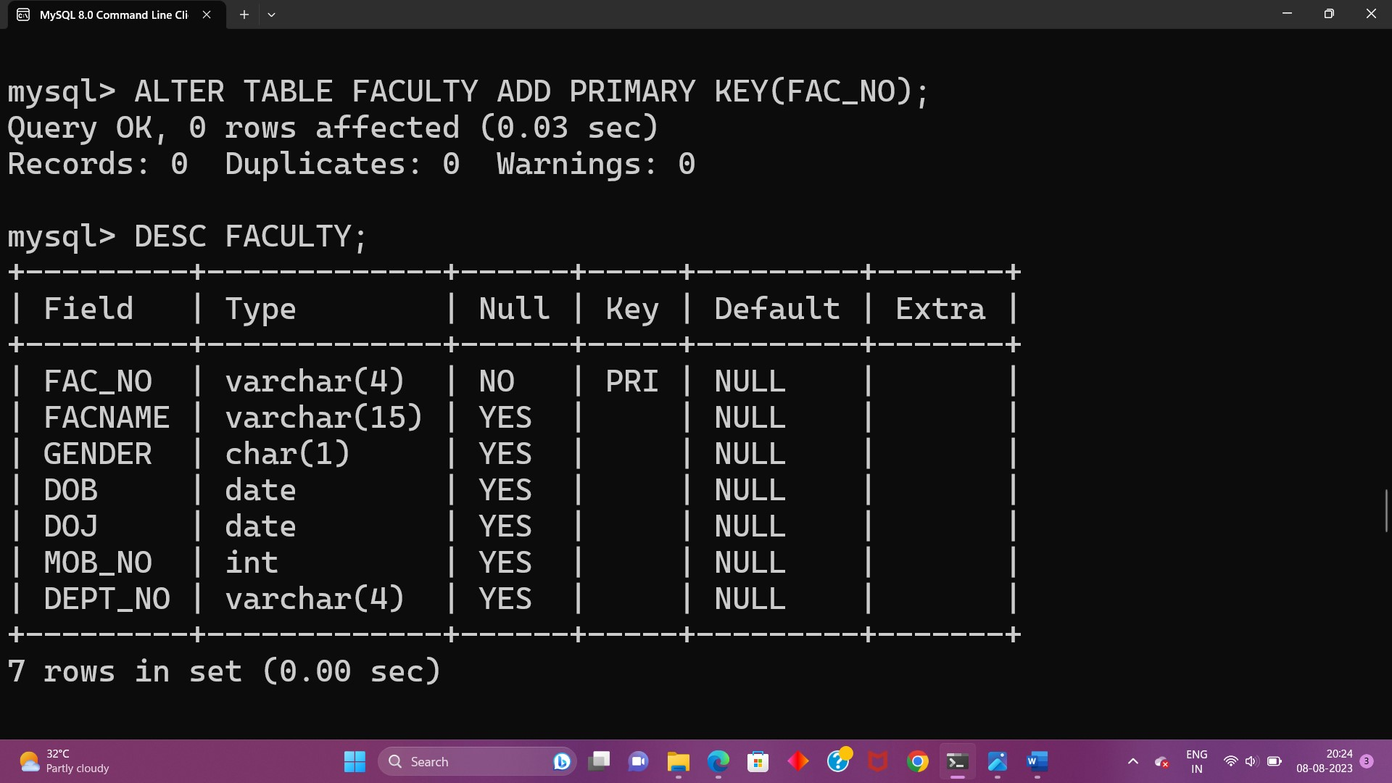

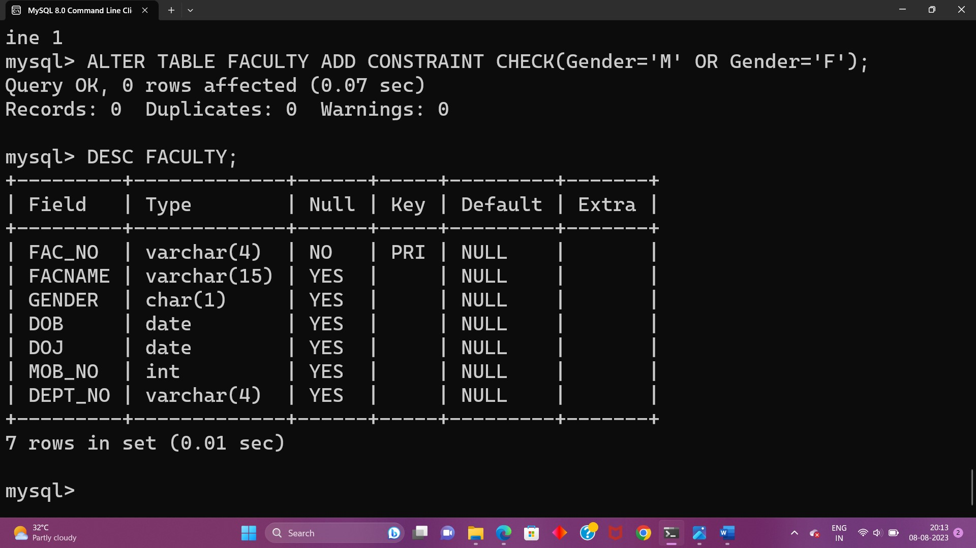

3.Alter the FACULTY table is successfully created,test if you can add a constraint FOREIGN KEY to the DeptNo of this table.

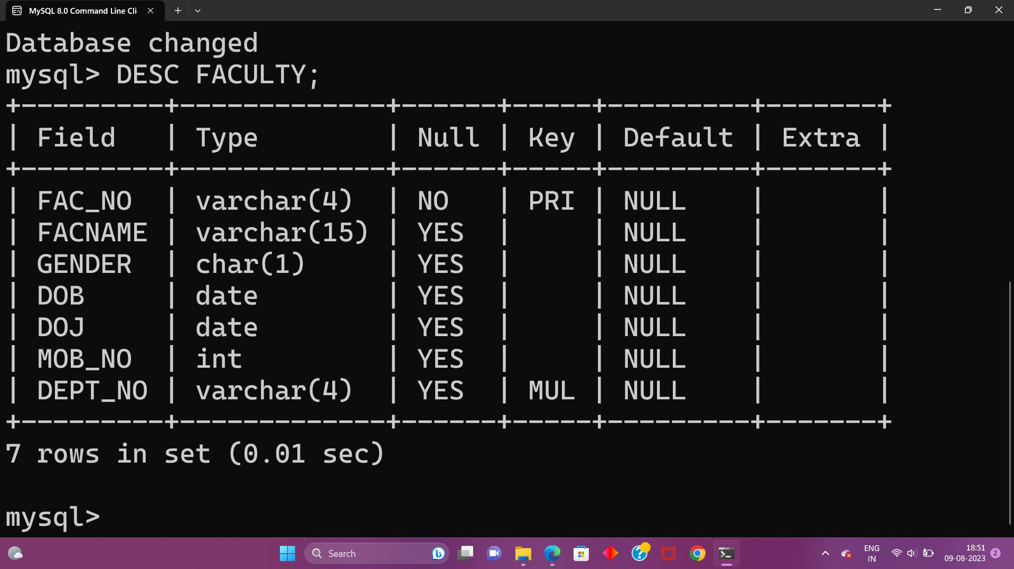

4.Alter the table name DEPARTMENT with following structure.

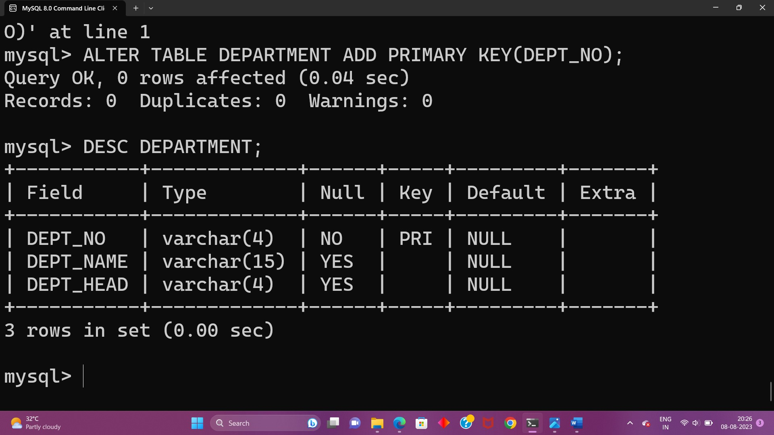

5.Alter the table name COURSE with following structure.

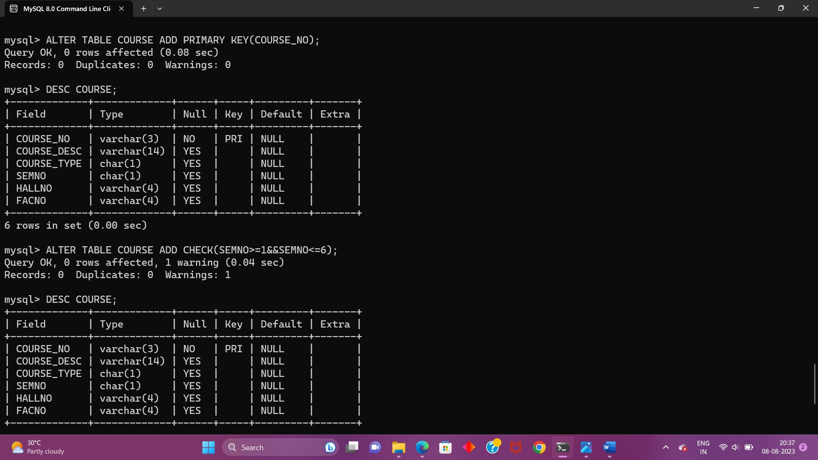

**EX-3**

1.Populate all the five tables with your own data.

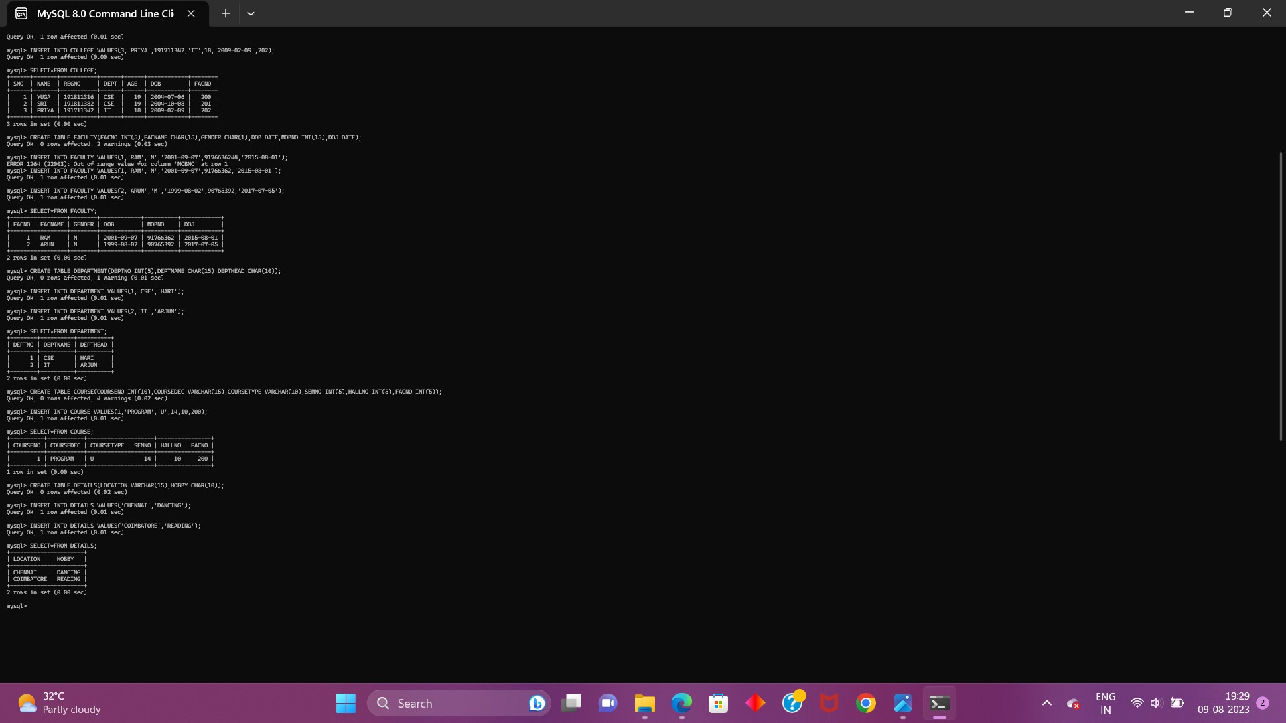

2.Update the value of the student name whose register number is’191711342’.

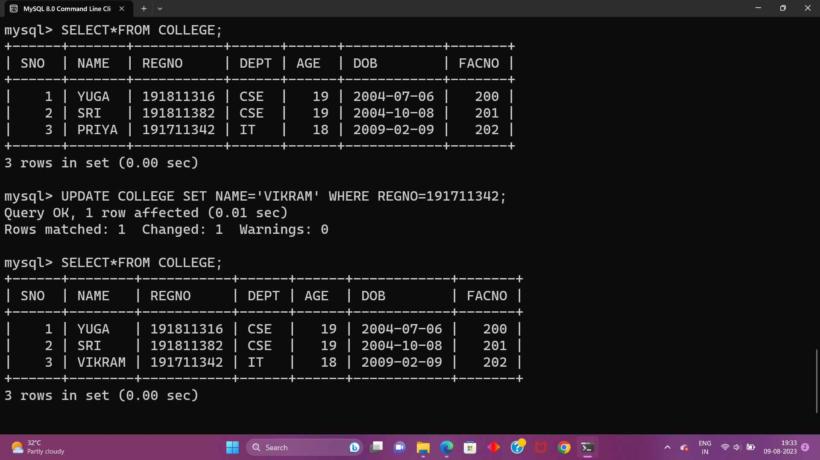

3.Delete the record in the table faculty,who resigned her job

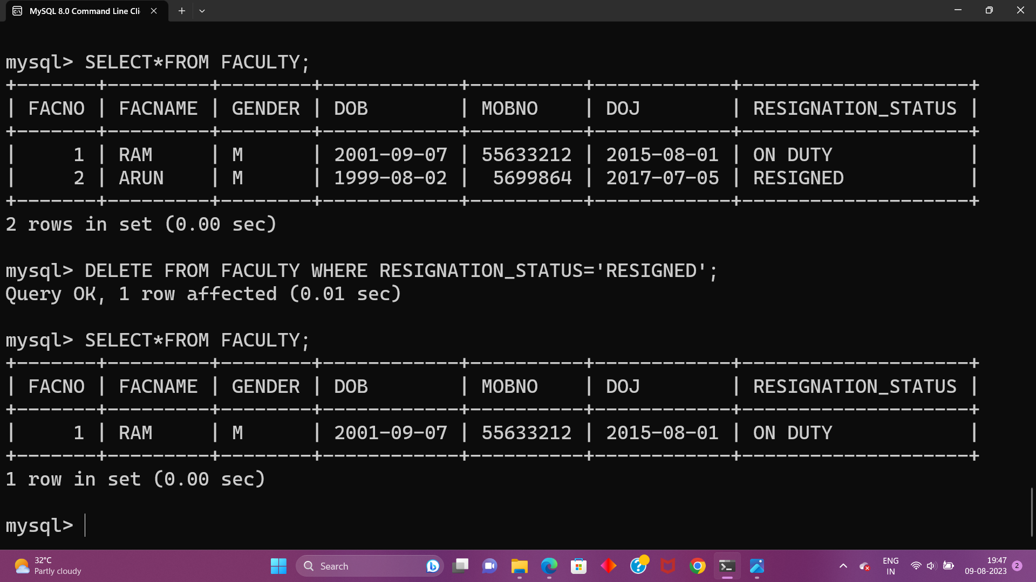

4.Modify the dob for the faculty whose name is ‘ram’ with a value ‘1983-05-01’.

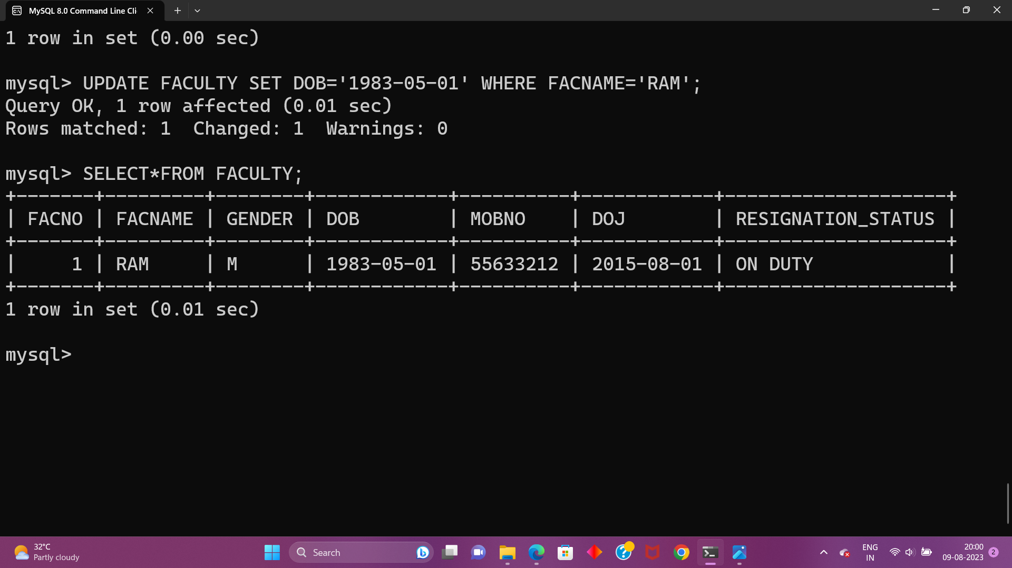

5. Remove all faculty who are having over 65 years.

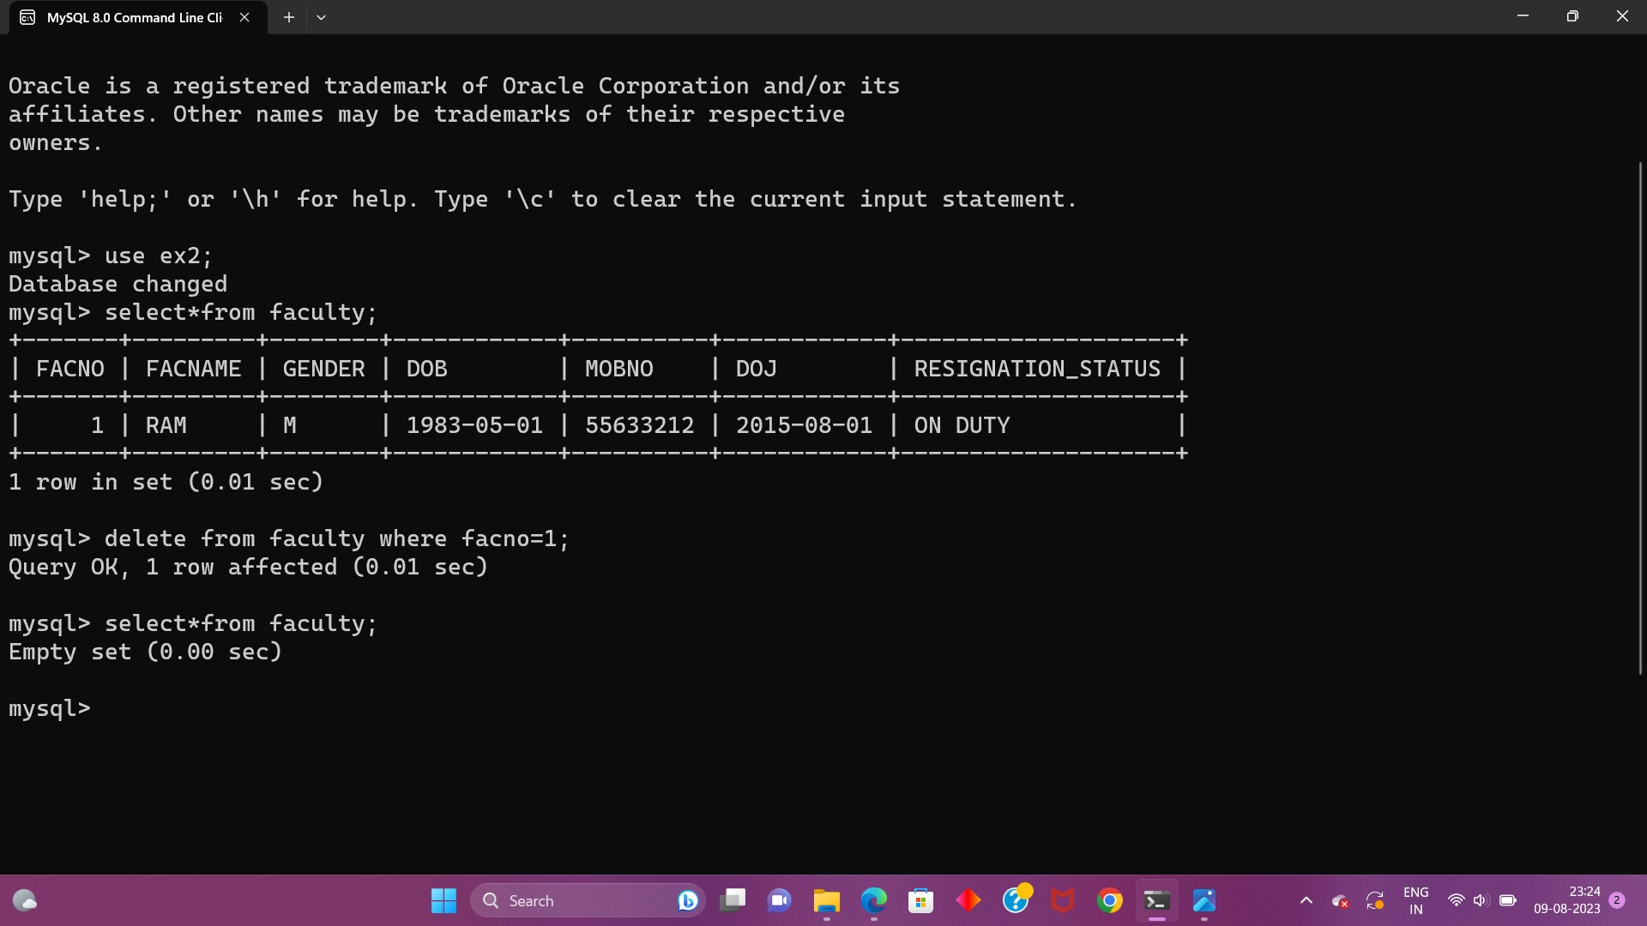

6.View all the records from five tables.

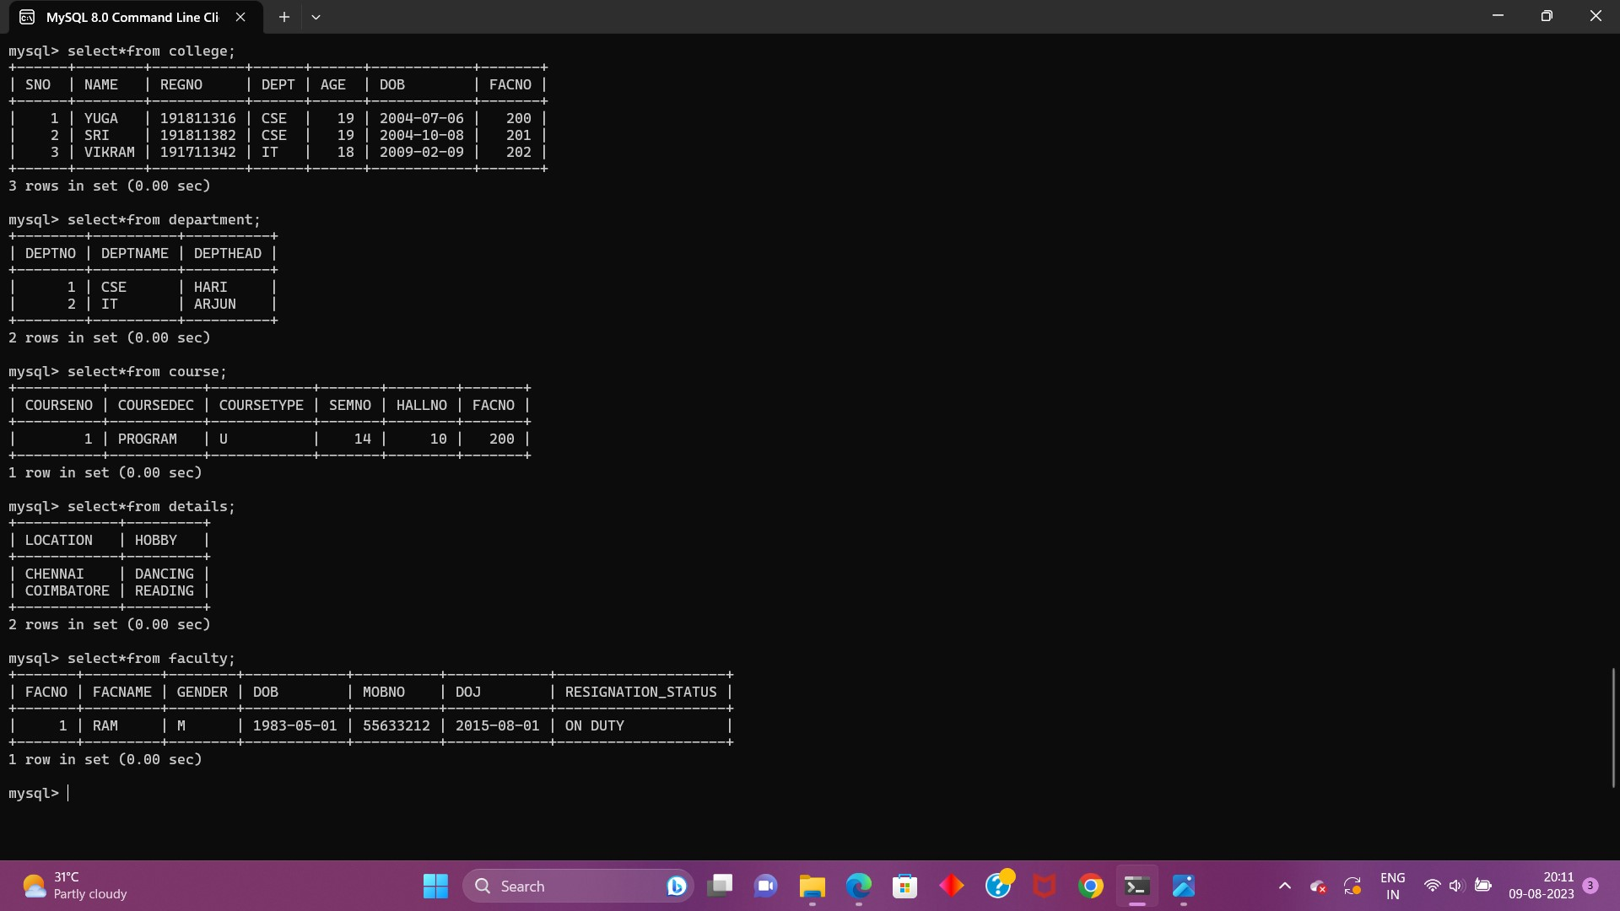

**EX-4**

WHERE:

1. The student counsellor wanted to display the registration number, student name and date of birth for all the students.

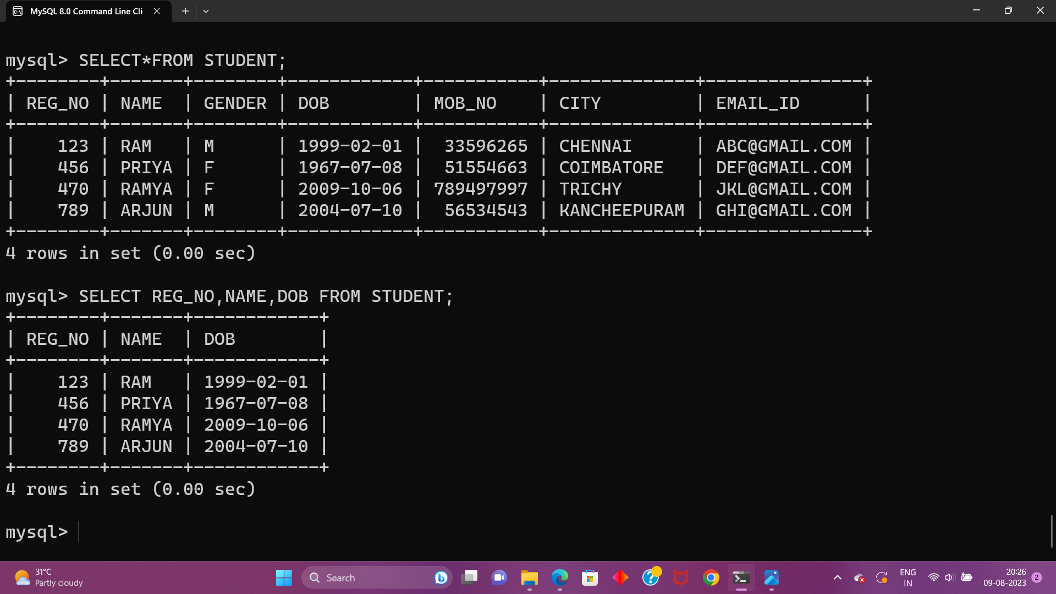

2. The controller of examinations wanted to list all the female students

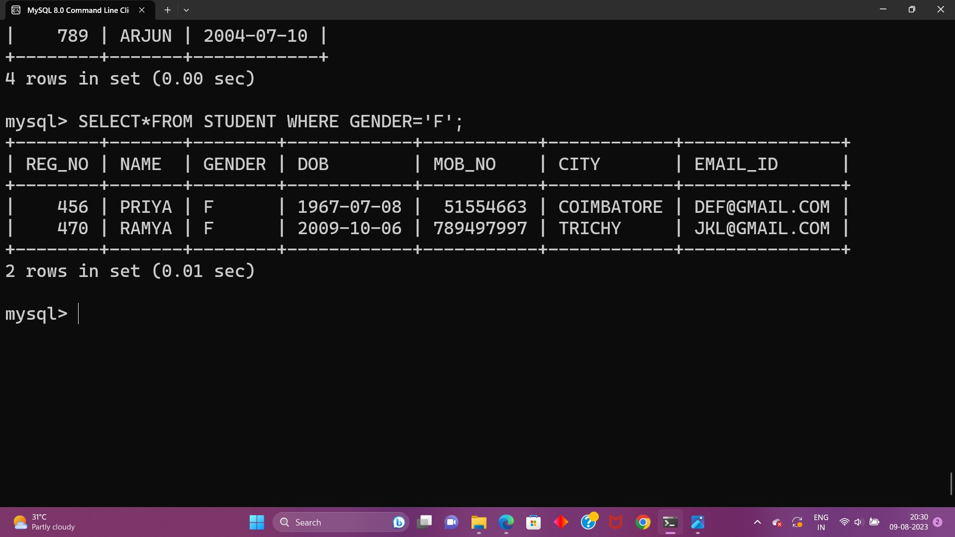

3.Who are the boy students registered for course with the course number “C001“

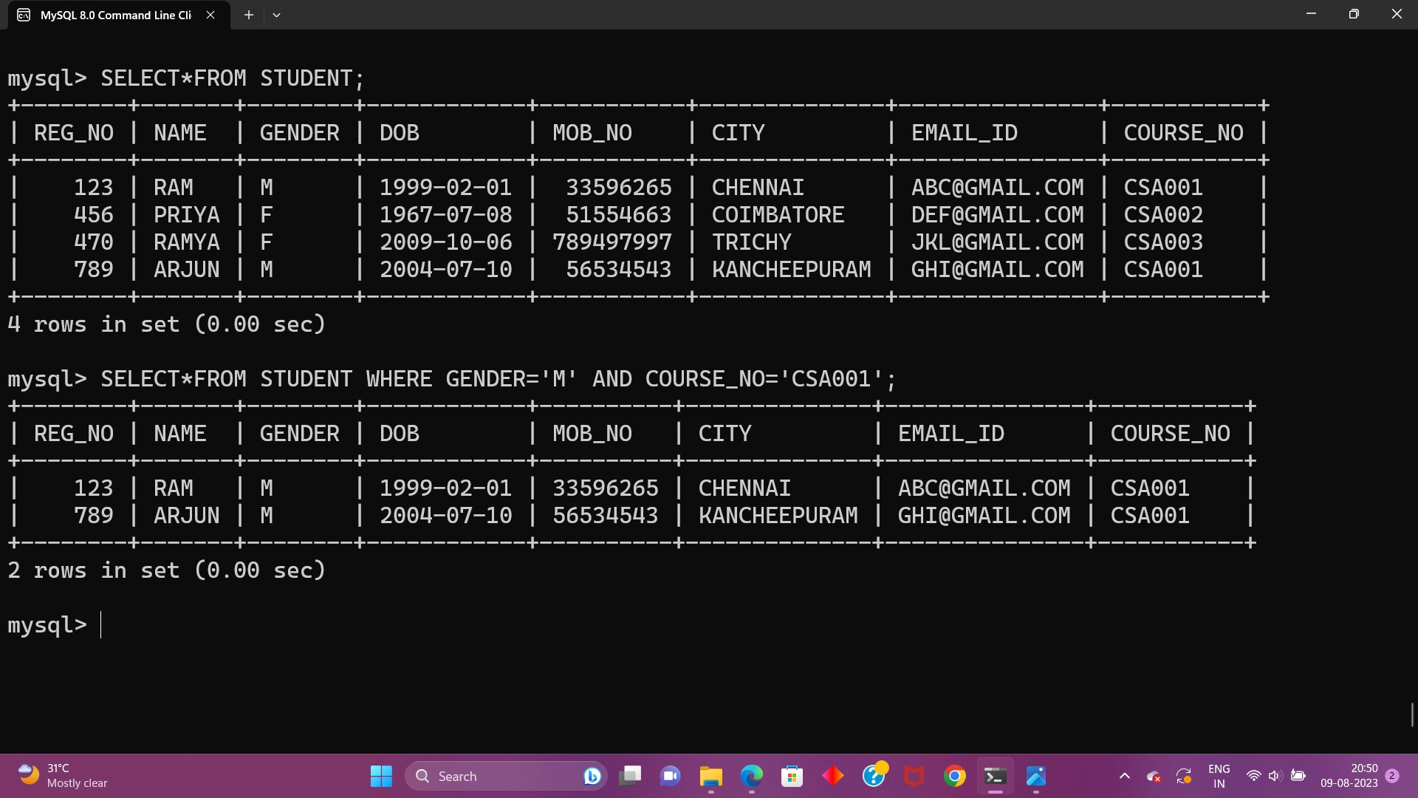

4.Display all faculty details joined before “November 2014”

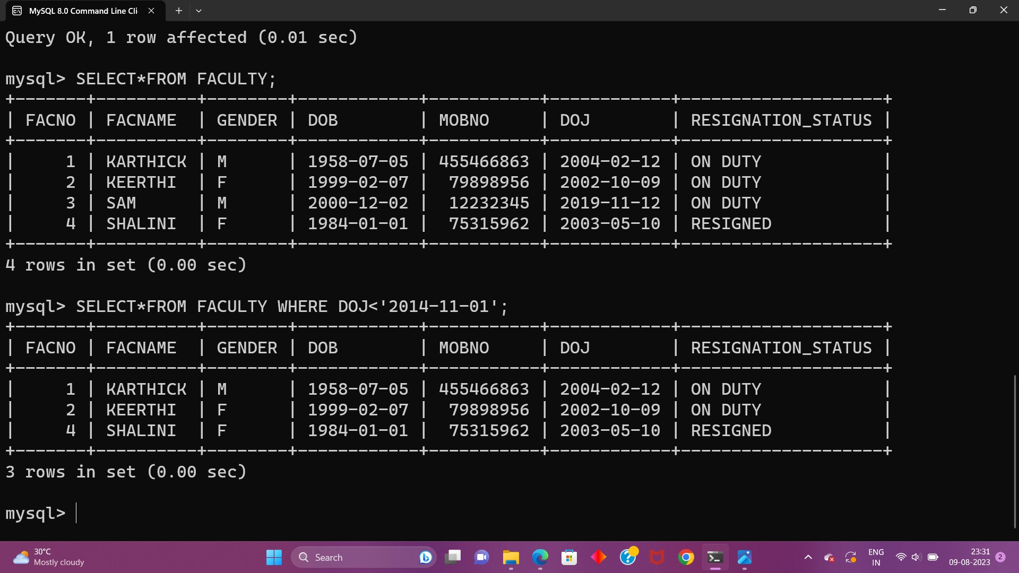

5.Display all the courses not allotted to halls

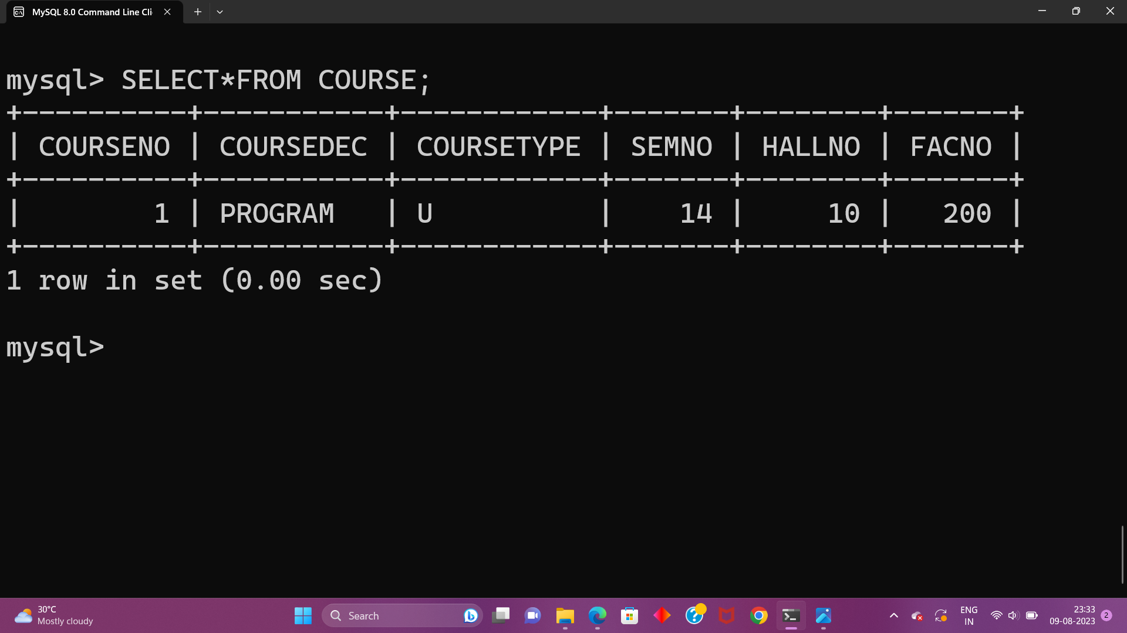

LIKE:

6.List the students whose name ends with the substring “ma”

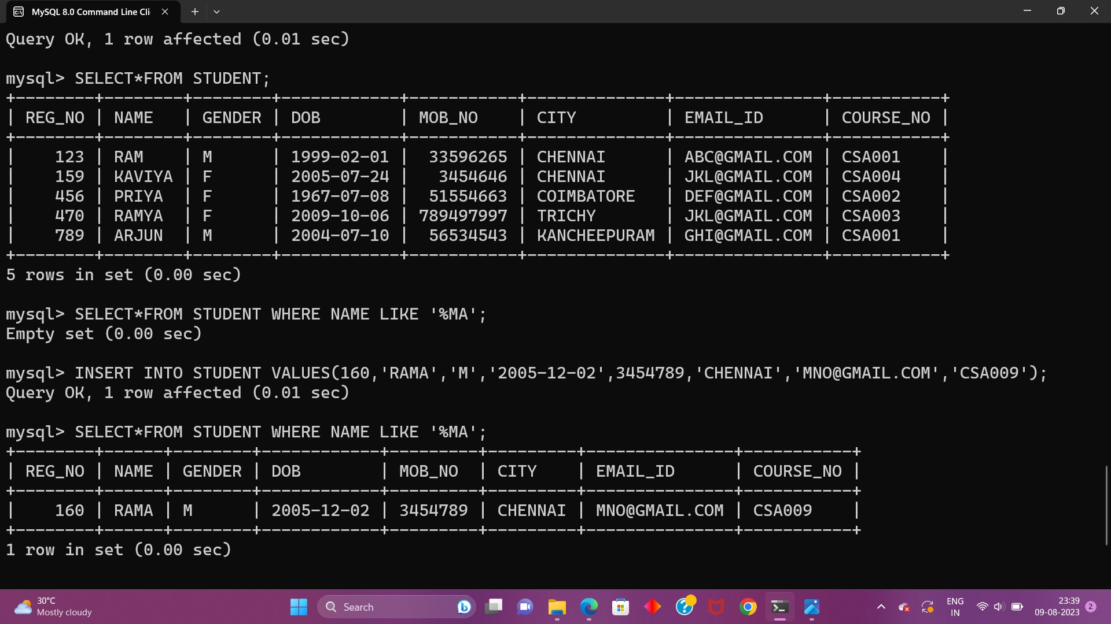

7.Display all students whose name contains the substring “ma”

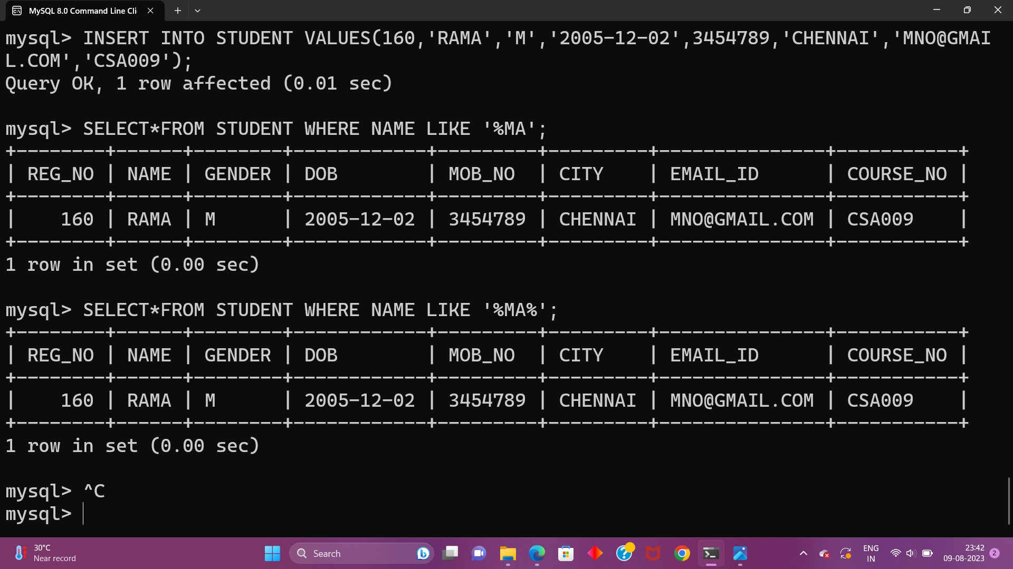

8.Find all the students who are located in cities having “Sal” as substring

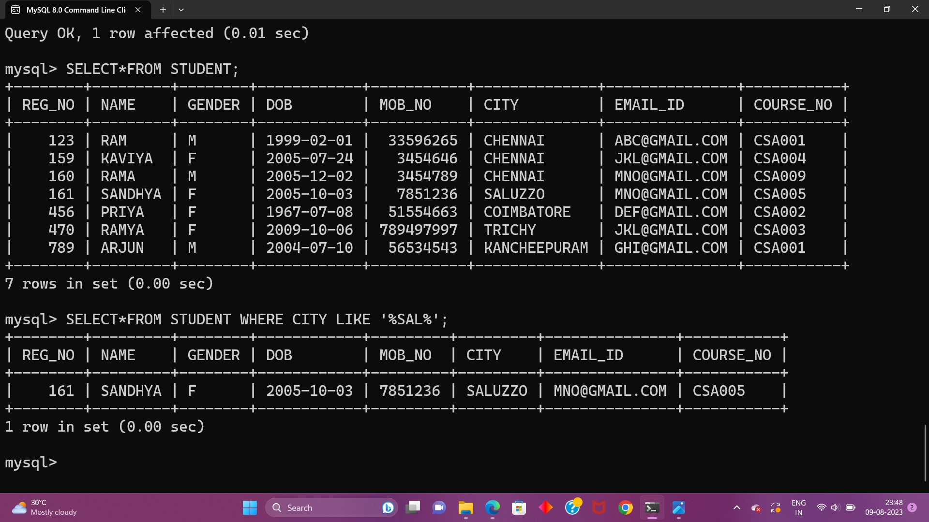

9.Display the students whose names do not contain six letters.

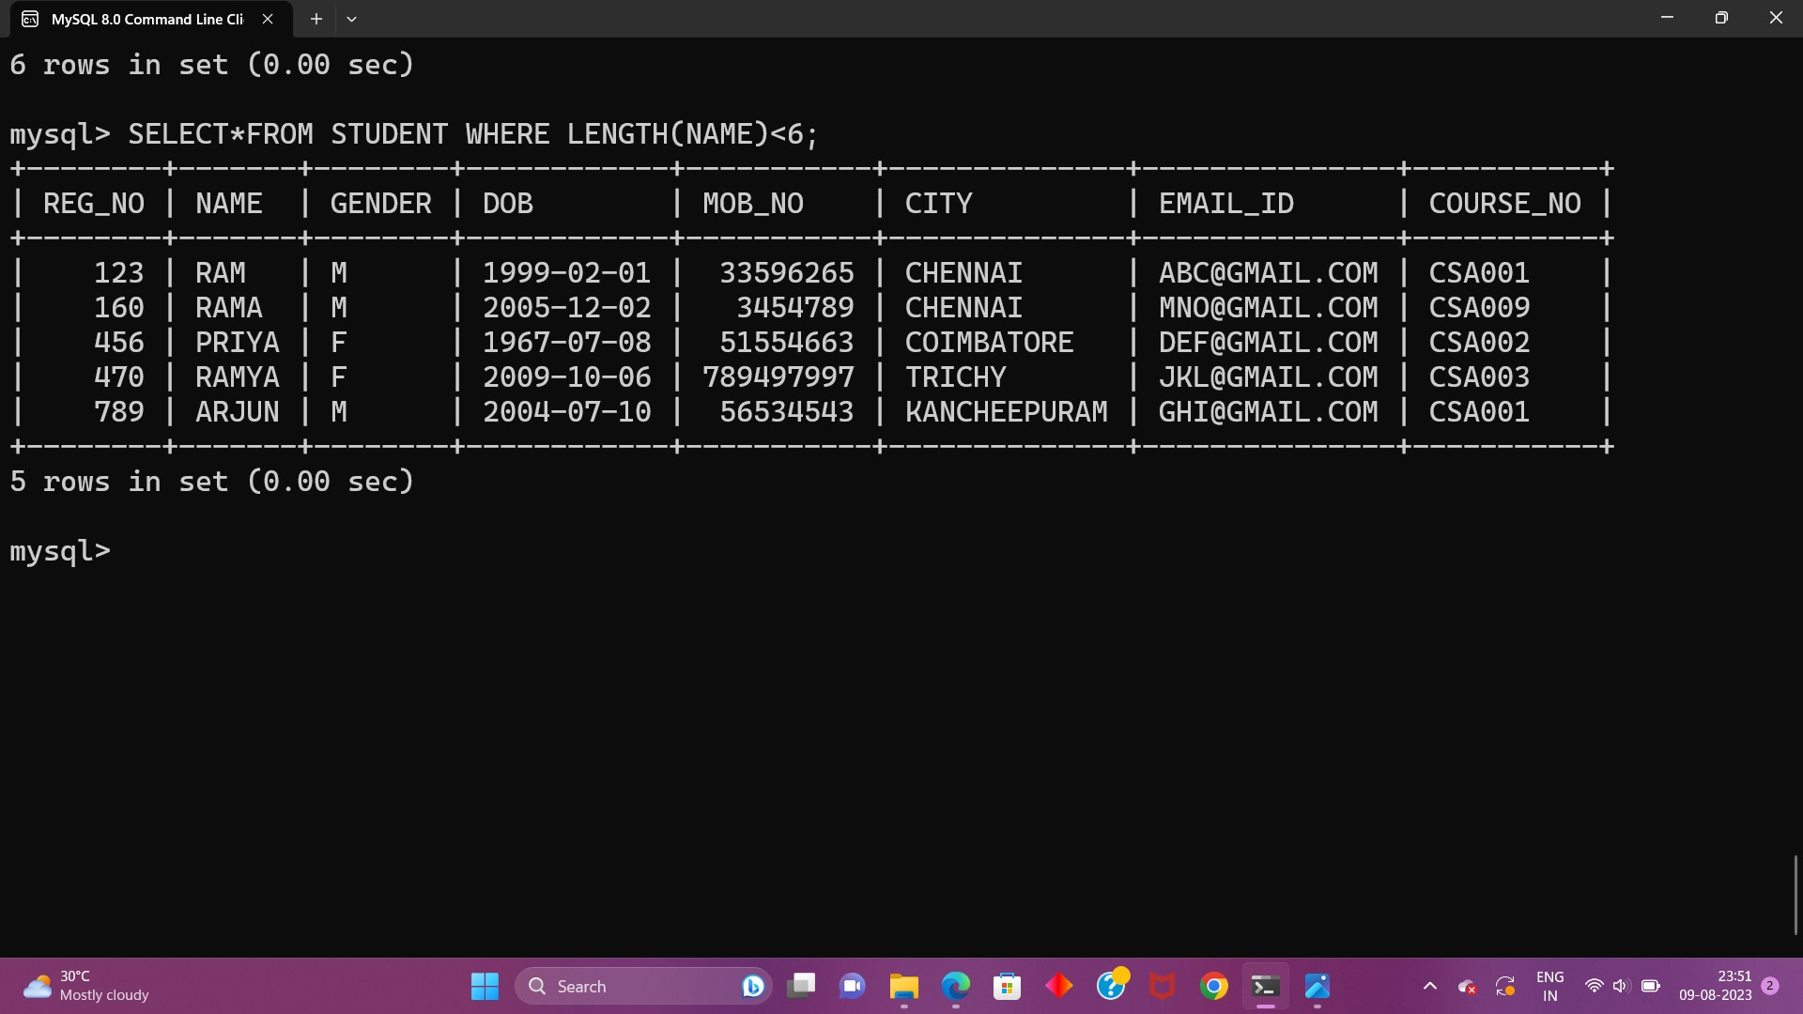

10.Find all the students whose names contains “th”

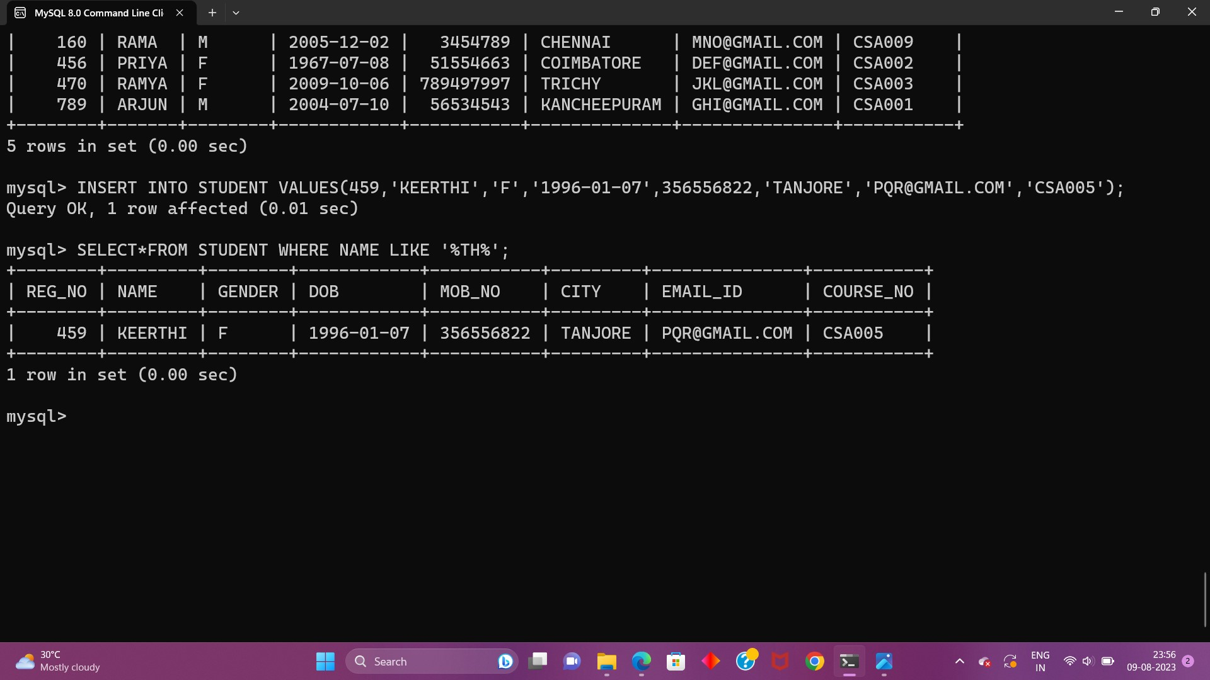

**EX-5**

1.List the type of the courses “Statistics” and “Programming”

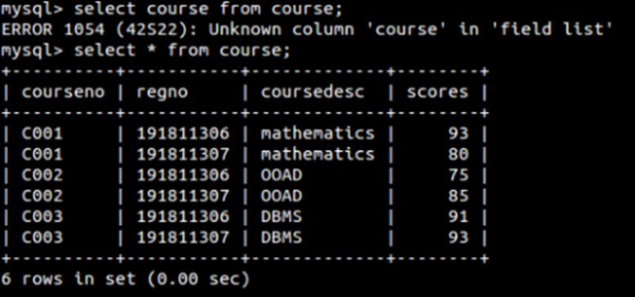

2.

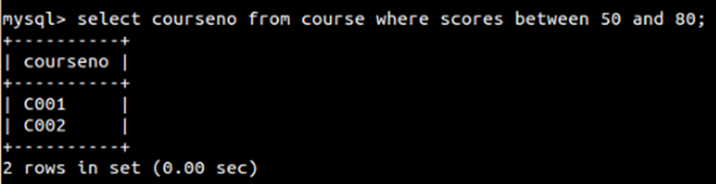

1.Find the average mark of “C002”.

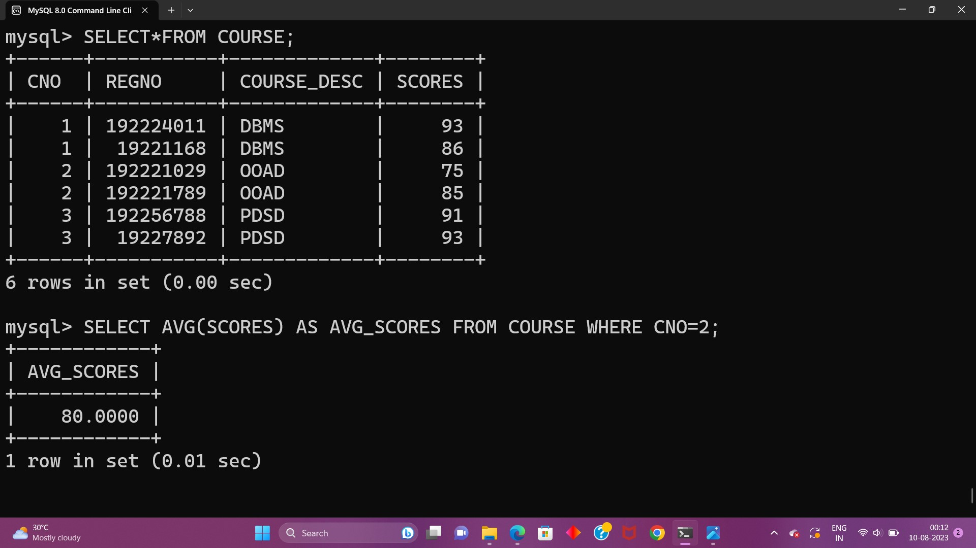

2. List the maximum, minimum mark for “C021”

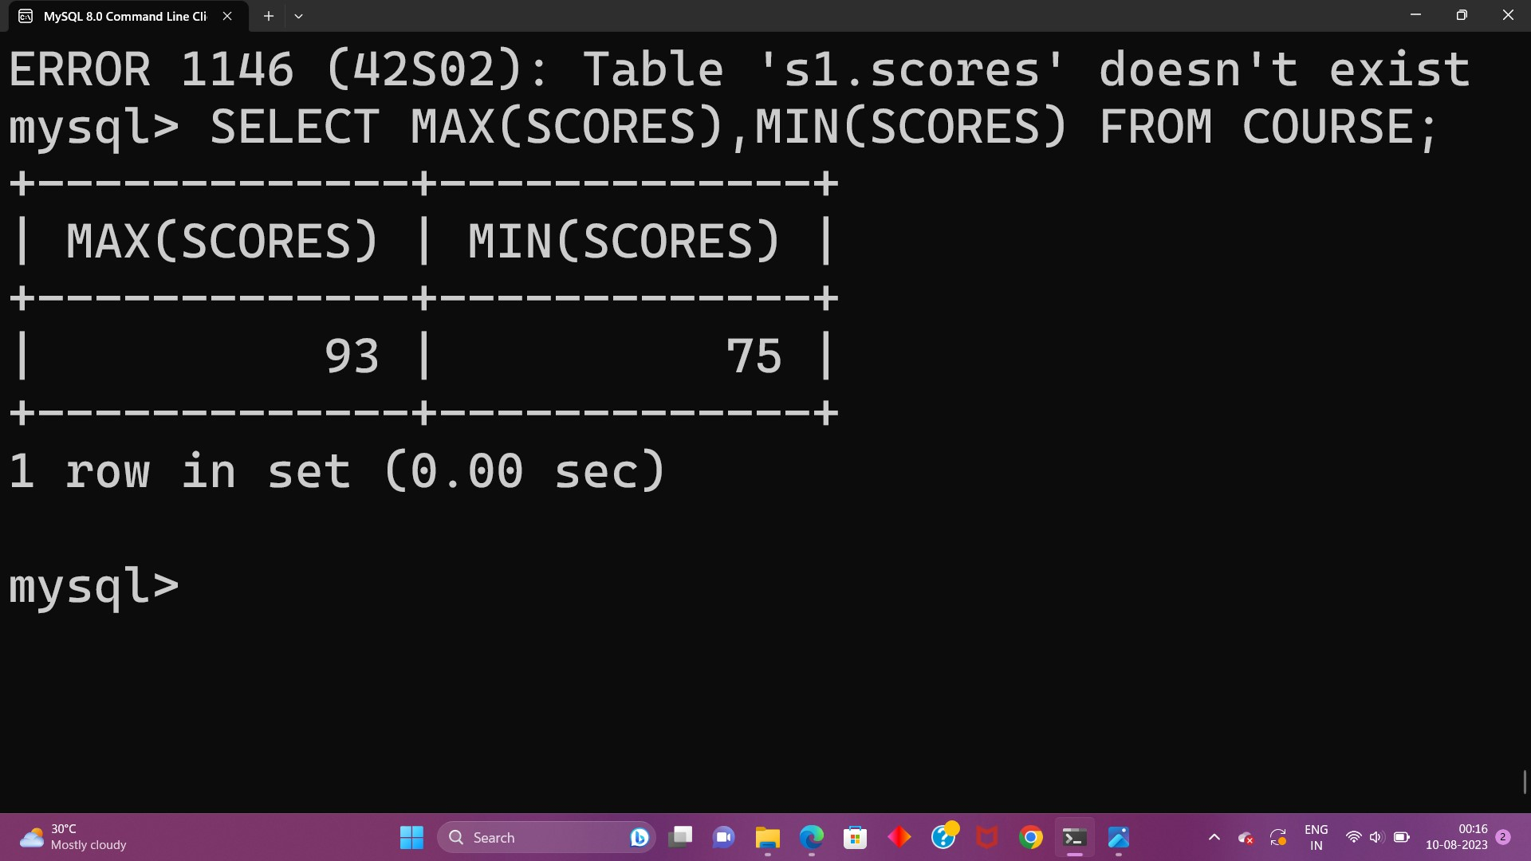

3.List the maximum, minimum, average mark for each subject in 5th semester

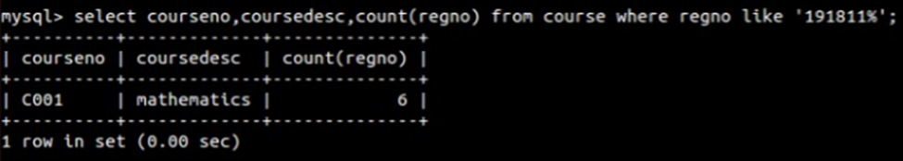

4.List the name of the courses and average mark of each courses.

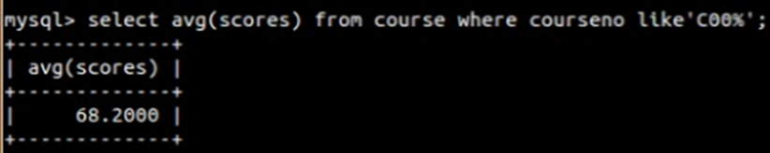

5.Calculate the sum of all the scores

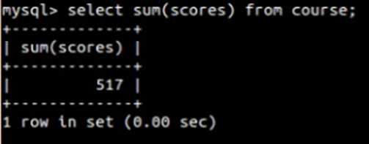

6. How many students are registered for each course? Display the course description and the number of students registered in each course.

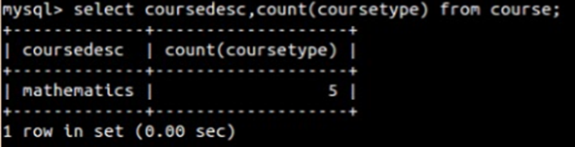

7.How many courses did each student register for? Use Assessment table



**EX-6**

1.

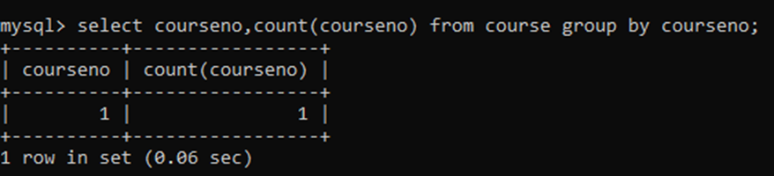

2.

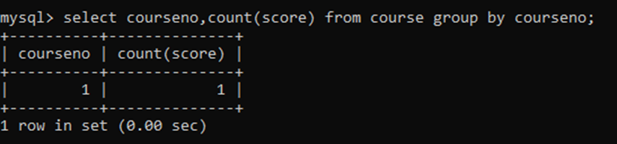

3.

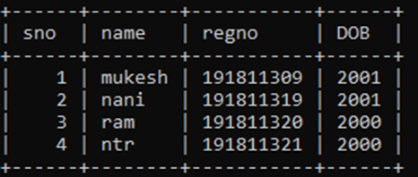

4.

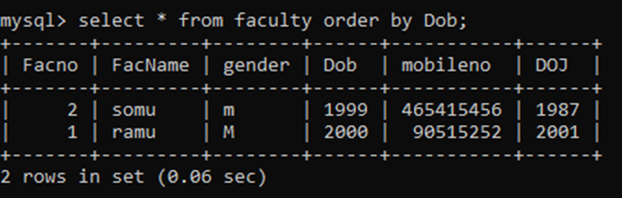

**EX-7**

1.

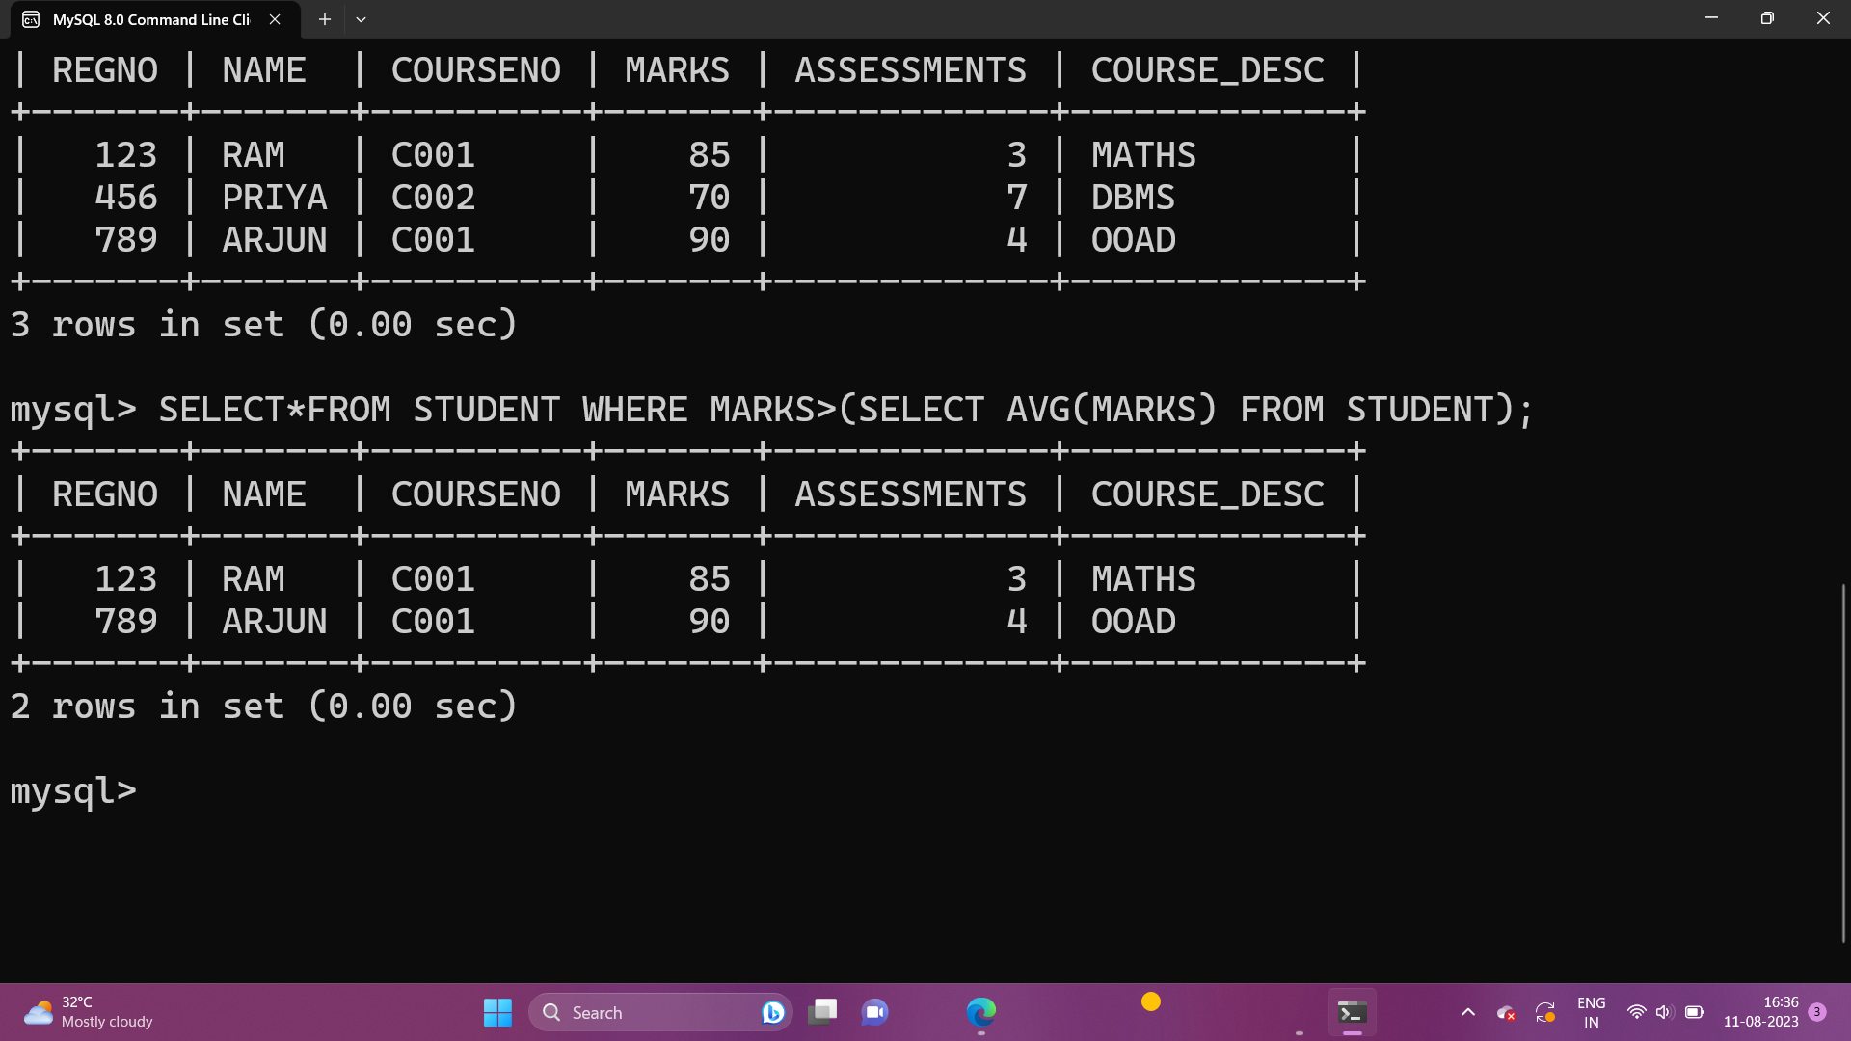

2.

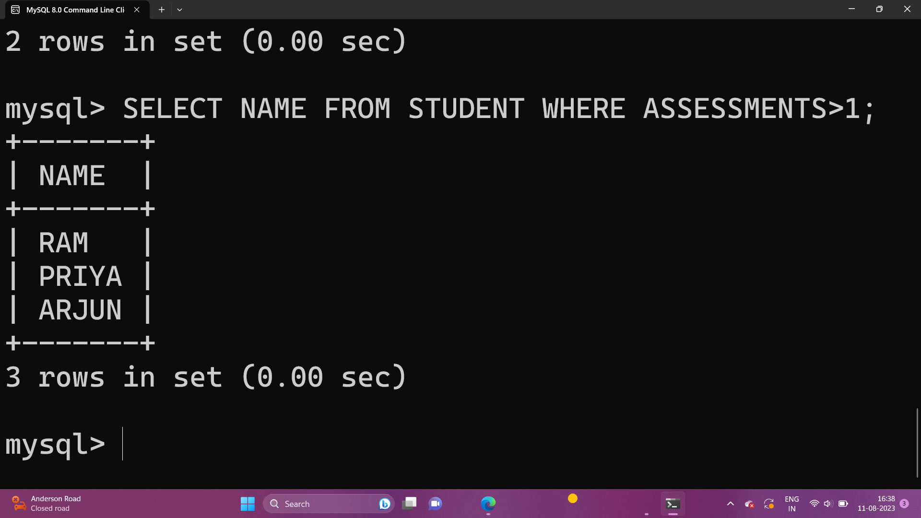

3.

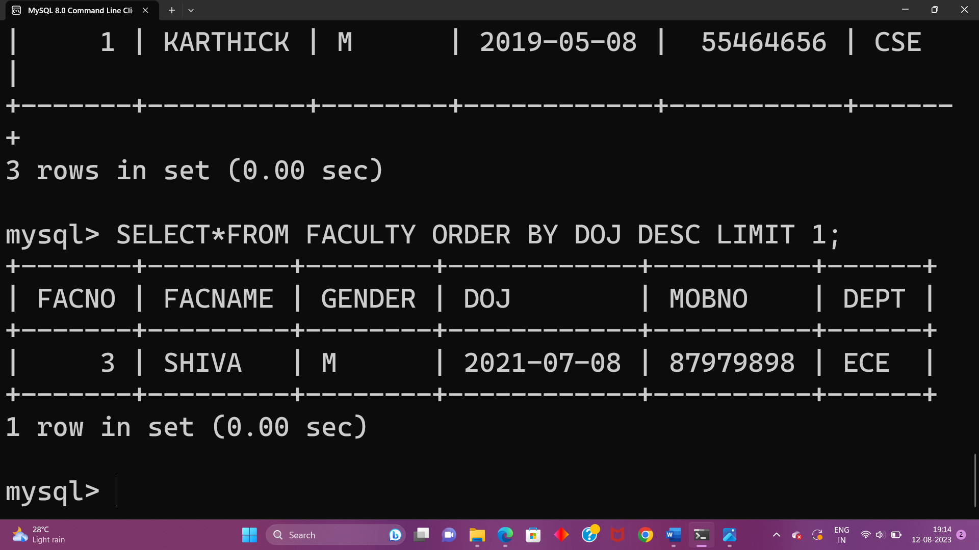

4.

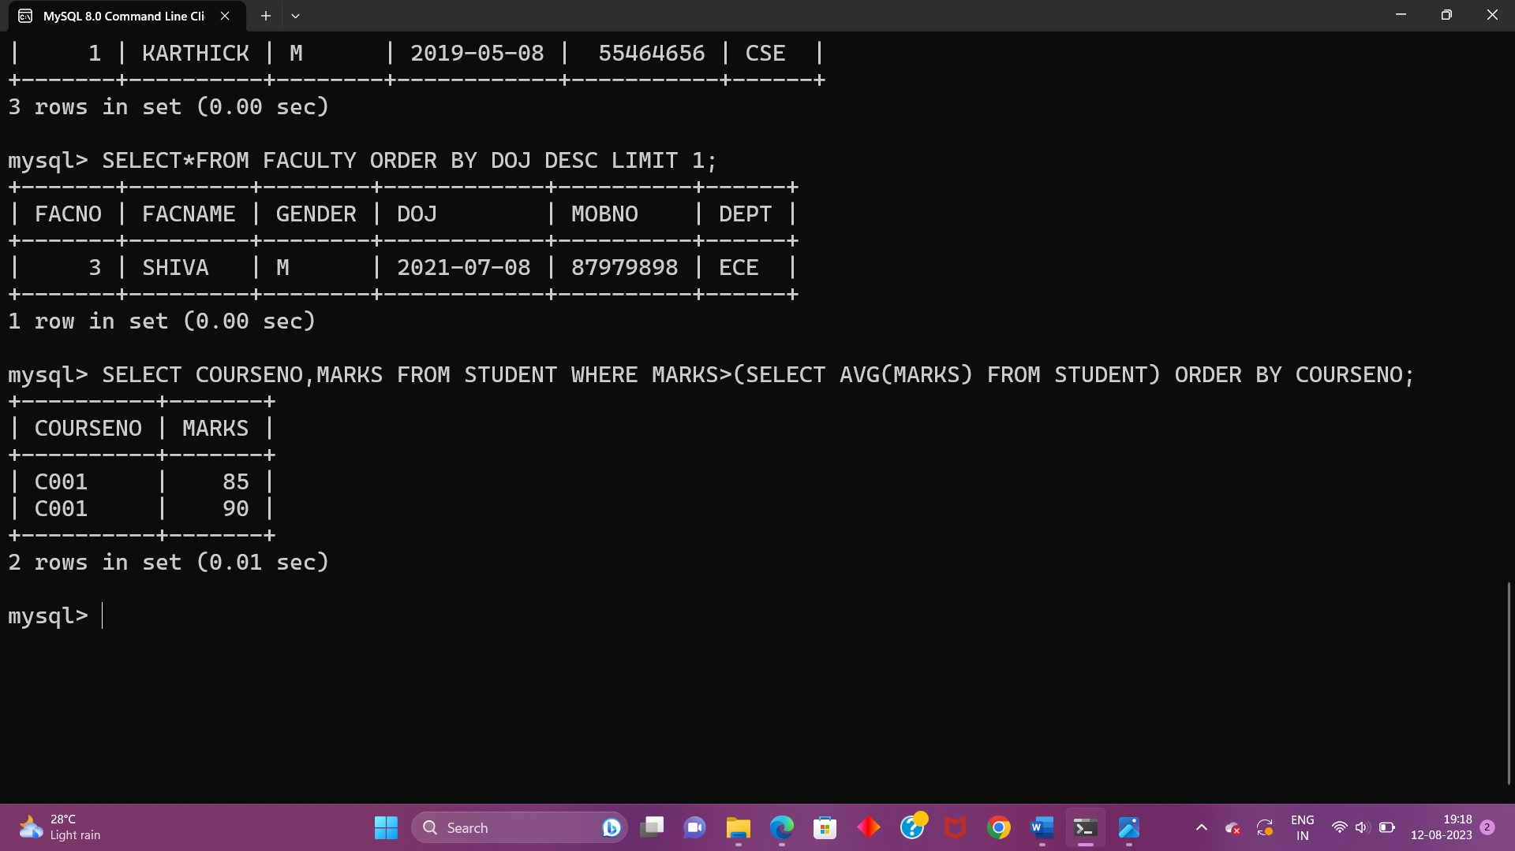

**EX-8**

1.

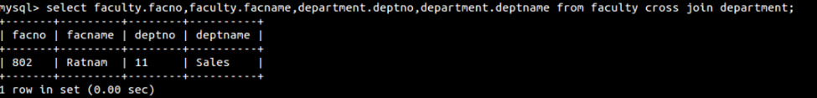

2.

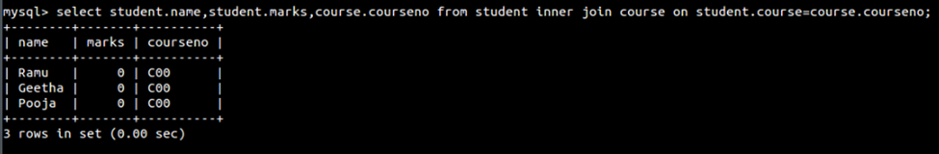

3.

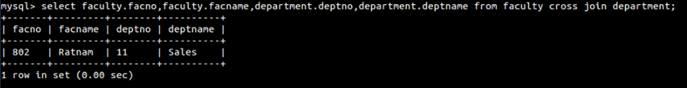

**EX-9**

1.

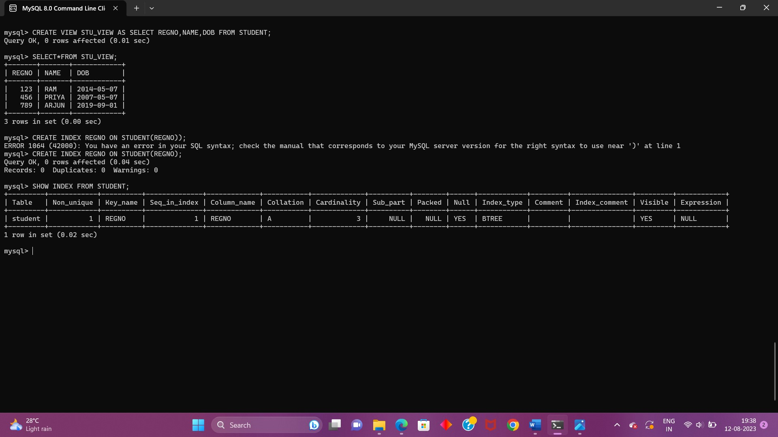

**EX-10**

1.

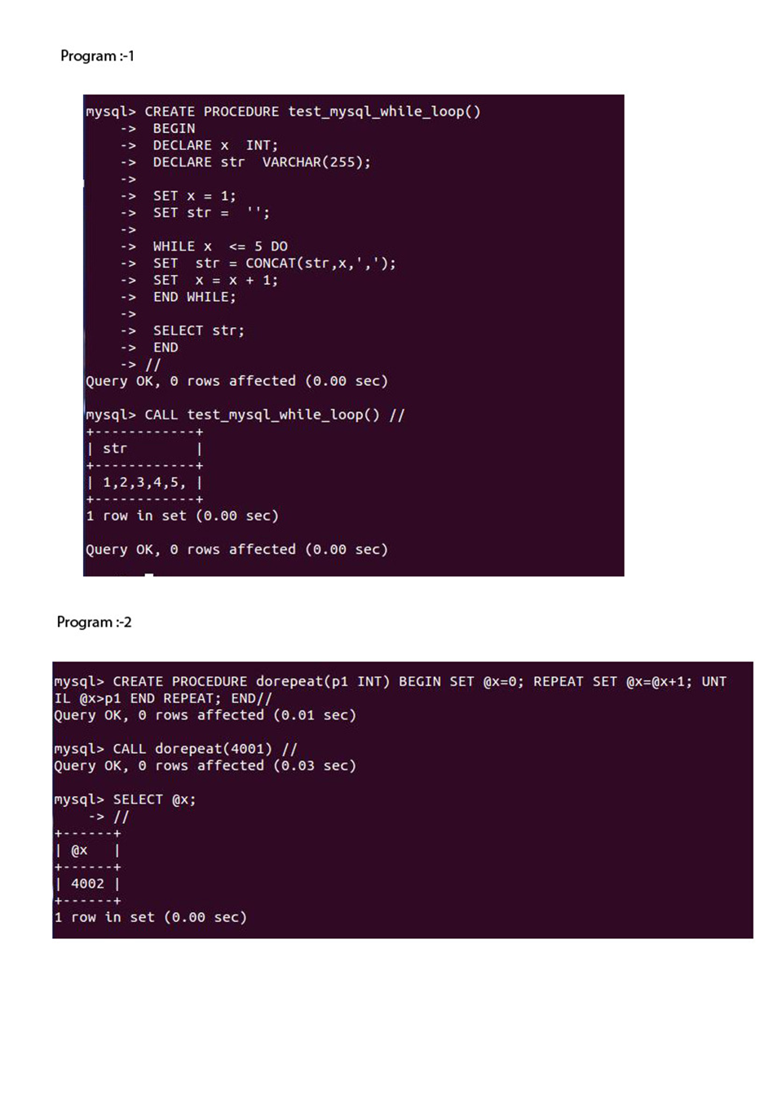

EX-11

1.

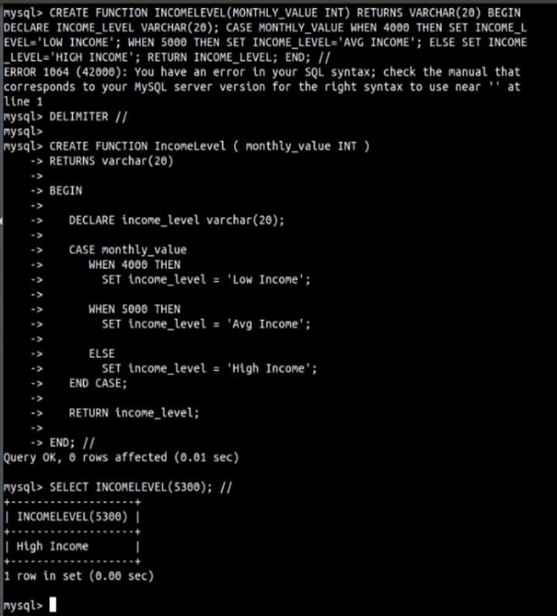

2.

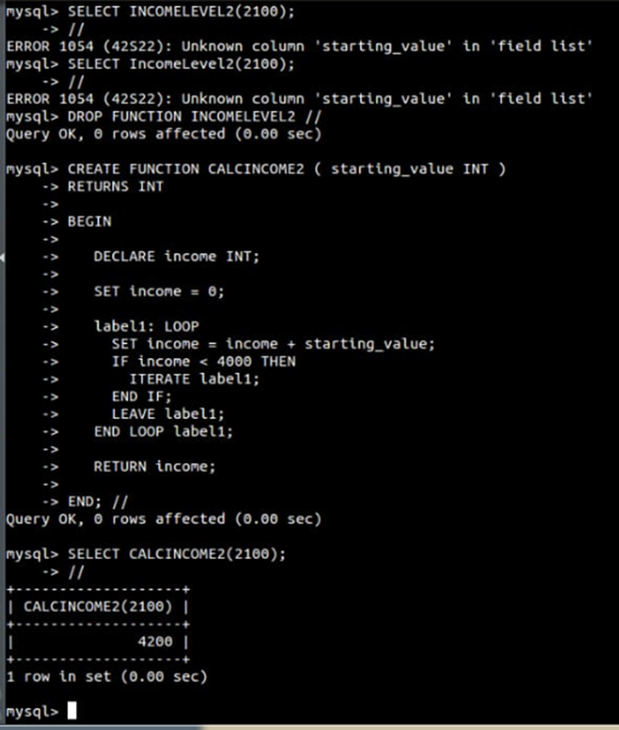

**EX-12**

1.

